NEWS 18 Apr 2019

CRU brings its Wire & Cable Conference to Brussels

Conferences & Events
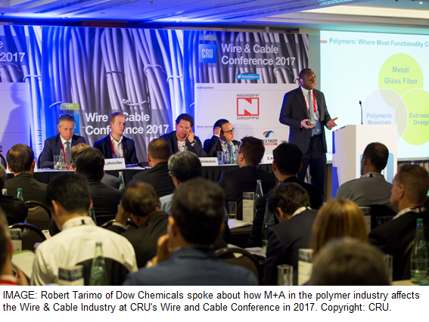
CRU, leading provider of cable news, analysis and consulting is to hold its 13th Wire & Cable Conference in Brussels on 11-12 June 2019.
The conference is well established as the premier meeting for leaders in the wire and cable industry, offering valuable peer-to-peer networking and presentations from international wire and cable manufacturers, distributors and other industry thought-leaders. The two-day conference will provide insights on emerging market opportunities and regional perspectives on changing trade dynamics. Delegates will also gain an in-depth understanding of specific power, communication, construction and automotive trends which may impact their business.
This year’s conference will have a special focus on the use of wire and cable in automotive industries and will open with a keynote presentation from Markus Thoma, managing director of LEONI Kabel GmbH. This will be followed by a fireside chat with Michael Finch, Head of Wire and Cable, CRU.
The agenda will also feature an Optical Cable Leadership Panel that will include Dr. Bernhard Deutsch, VP and general manager, Optical Cable, Corning Inc; Antoni Bosch, VP, Telecom Solutions, Prysmian; and Brad R Johnson, president, Superior Essex Communications.
Other highlights include Laurent Schmitt, secretary general, ENTSO-E who will also make a keynote address on new EU legislation and achieving clean energy package targets; and Hamid R Al Zayani, managing director of Midal Cables will share his insights into the Middle East wire and cable industry.
“Wire and cable companies are having to provide products and services that are increasingly high-tech in order to keep up with government targets for electric and connected vehicles, the energy transition to generate electricity from clean and renewable resources, Smart Grids, Smart Cities, 5G, IoT and Factory Automation,” commented Natalie Noor-Drugan, senior analyst, CRU and editor-in-chief of Wire & Cable News.
“Companies are also increasingly having to prove that their supply chain is sustainable, that their products have a low environmental impact and comply with the latest regulations. The most successful producers are those that have value added, highly differentiated products and services. Taking a 360 approach, working within a larger ecosystem, informing policymakers, educating customers and stakeholders, as well as creating and providing innovative and useful end-to-end services in collaboration with customers and end users,” added Mrs Noor-Drugan.
This year’s Wire & Cable Conference in Brussels aims to find out how the cable industry is striving to achieve some of these goals within the various industry sectors they cater for.
Registered delegates will be given the opportunity to visit Aurubis’ copper production facility at Olen. Starting with one of the largest copper scrap yards in Europe, the tour will cover the full process from scrap to semi-finished products.
Nicola Coslett, CEO, CRU Events added "Brussels offers an interesting meeting point for industry leaders, as the centre for European policymaking. The conference will explore the direction of the EU’s key construction, power and communication projects; and how wire and cable quality controls and standards have been implemented. As with previous years, the event will offer dual streams covering both energy cable and communication cable issues, bringing together the entire wire and cable supply chain."
The CRU Wire & Cable Conference will be held on 11-12 June 2019 at Steigenberger Wiltcher’s, Brussels, Belgium. For further information please visit http://bit.ly/2v9IJKF

